OO Programming Fundamentals

Practical Week 6 – 20th October 2014

Create a Practical Week folder in your Java folder on your G drive

G:\Java\Practical Week 6

- Save all the following exercises into the Practical 6 folder

Exercise 1:

Write a program that prints your name (not my name) to the screen 100 times. Use a For loop.

Create project in Practical Week 6 folder as: ex6a
Sample Output
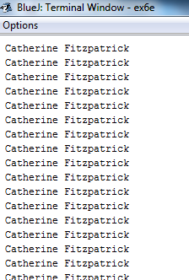

Exercise 2:

Write a program which asks the user to enter their name and print that name to the screen 1000 times.

Create project in Practical Week 6 folder as: ex6b
Sample Output
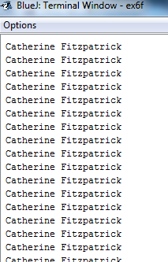

Exercise 3:
Write a program using a For statement to print the numbers from 1 to 10 inclusive.

Create project in Practical Week 6 folder as: ex6g
Sample Output
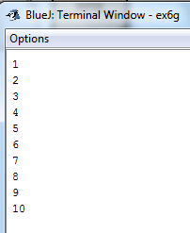

Exercise 4:

Write a program using a For statement to print the numbers from 10 to 1 inclusive.

Create project in Practical Week 6 folder as: ex6d
Sample Output
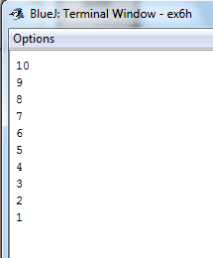

Exercise 5
Write a program using a For statement to print the numbers from 1 to 20 (With a for loop only).

Create project in Practical Week 6 folder as: ex6e
Sample Output
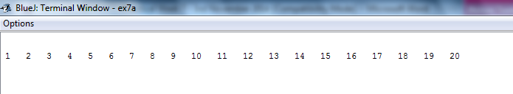

Exercise 6
Rewrite Exercise 5 to print the even numbers from 1 to 20 - this time use a for loop and an if statement. Use the if statement to determine if the number is even.

Create project in Practical Week 6 folder as: ex6f
Sample Output

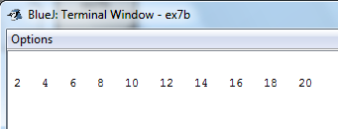

Exercise 7:
Write a program which accepts 5 numbers from the user using a for loop. The program should add the 5 numbers and display the total. Also, display the average of the numbers.
- Ask the user to enter a number
- Take in the number and store it in a variable num
- Use a for loop to repeat this 5 times - accepting 5 values from the user.
- Use a new variable total to store the running total total of the 5 values - (first num entered + second num entered.....)
- The program should add the five numbers and display the total.
- Calculate and display the average of the numbers.
- Use a maximum of 4 variables!
- One variable to store the number entered by the user
- One variable for the for loop counter
- One variable to store the running total
- One variable to store the average (if required)

Create project in Practical Week 6 folder as: ex6g
Sample Output
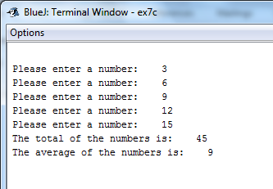

Exercise 8:
Write a program which asks the user to enter a number greater than 0. The program should then count from 0 to the number entered by the user (with each number on its own line). Use a for loop.

Create project in Practical Week 6 folder as: ex6h

Sample Output
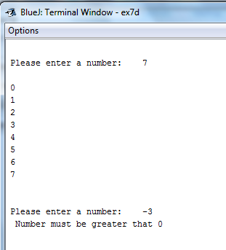

Completing this weeks’ Practical:
- When you submit work, you will send it in zip file format.
- To create a zip file of your practical work:
  - In Windows Explorer, right click on the Practical Week 6 folder that contains your work.
  - When the context menu appears, choose the Send to option, followed by the Compressed (zipped) folder.
  - This will create a new file called Practical Week 6.zip in your current folder
- Note: If you are using your own laptop, you can choose to install very good (and free) compression software called 7zip. Just search for it in Google and download it.

*** It is this zipped file that you will upload into Moodle.***

